 | CFAS Enterprises Inc.  After Market Utility Power Equipment Brokerage  Mailto:Staff@CFASPower.com  Turbine URL: http://CFASPower.com/Inventory.html  Reciprocating URL: http://CFASPower.com/Recips.html
GTG_1044MTN_Fm5LA.doc

1 x Used GEC Alstom Fm 5001LA /50Hz In Excellent Condition

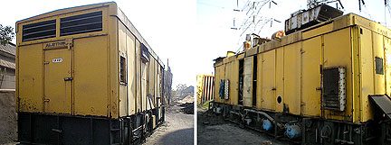

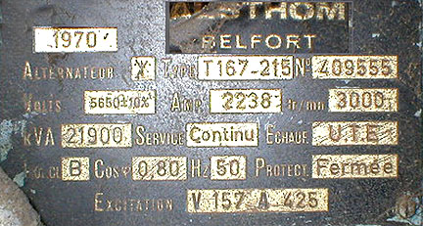

Price „as/where is“ Asia Minor USD $1,850,000
Est.Cost Dismantling Crating shipment FOB USD $120,000
Gas Turbine
Manufacturer: GEC- Alstom
Type: LA
Model: Series 5001
Fuel Naphtha / HSD
Power Output: 14.9mw ( Base Load )
16.9mw ( Peak Load )
Heat Rate: 3613 K Cal / Kwh
Efficiency: 23.8% (Base Load )
24.3% (Peak Load )
Firing Temp: 899c (Base Load )
Exhaust Temp: 498c (Base Load)
Start Up Fuel: HSD

Generator
Make: Alstom Belfort
Cooling: Air Cooled w/Closed Circuit
Bearing: One separate bearing & one bearing combined with reduction Gear
Nominal Power Output: 17500Kw
Apparent Power output: 21900 Kva
Speed: 3000 RPM
Voltage: 5650V +/- 10%
Phases: 3
Frequency: 50hz
Connection: Y
Duty: Continuous
Strator Insulation: Class F
Motor Insulation: Class F
Nominal Excitation Voltage: 157 VDC
Nominal Excitation Current: 425 ADC
Synchronous Resistance Xs; 214
Direct Tranient Resistance Xd: 21.6%
Direct Subtrancient resistance Xd: 14.7%
Short Circuit radio: .05
Rotor Resistance at 20 Deg C: 0.270 ohms
Strator Resistance at 75 Deg C: 0.00848 ohms

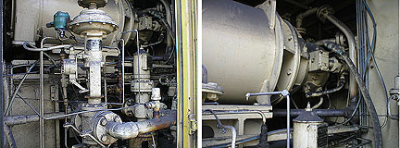

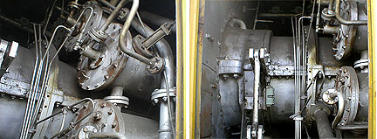

Excitation System
Excitation System: Static DC Magnetic Amplifier type with AVR
Excitation Transformer: 50KVA, 5000V/250V. 3 Ph, 5p00hz, Air Cooled, Indoor Duty
Single Phase CTs-6 Nos. 2600A/180 A/15A Compounding CT
CT for Differential Protector- 6Nos. 2500A/5 A Class PS
Choke-3 Nos. 34 mH, 140 A
Rectifier Diodes-6 Nos. 175V. 475A
Excitation Contactors: Bipolar 40A
Excitation Contactors: TriPolar 250A
Protection Resistors: 47 ohms/950Kw
Field Current Limiting Resistor: 47 ohms/950Kw
Motorized Rheostat For Voltage adjustment in Manual Mode
Motorized Rheostat For Voltage adjustment in Auto Mode
Transformer for manual Adjust. 1 No. 205/15/2 phase 50 hz
Potential Transformer-3 No. 5500v/110v 50VA for AVR
Potential Transformer-3 No. 5500v/110v 100VA for Protection and Metering
AVR: Gain 10-30, 15A under 35V Burden 550VA
PT Chamber (2Rx100x10mmcu): Metal clad Chamber w/Insulator w/Busbar

Operation History
- I D No.: 401
- Yom: 70's By GEC Alstom

Overhaul And Modification
- Fuel Original: Liquid & Natural Gas
- Modification To Nat Gas: Feb. 1982 At 50,000 Hrs
- Total No Of Hours( 2/1996): 85000
- No Of Start Approx: 500
- Last Overhaul Date: June 1993
- Hrs Since Last Overhaul: 4000
- Next Overhaul Due After Hours: 25000
- Mod Into Steam Injection: May 1993
- Gas Turbine Commisioned At Negcl: 7/11/1998
- No Of Hours Run For Comm : 87 Hours
- Date Of Comm Production: 03/05/1999
- GT Modified To Naphtha Firing: July. 1999
- Exhaust Plenum Modification: Feb. 1999
- G T Best Station Out Put: 14.22 Mw
- Heat Rate: 3900 K Cal / Kwh ( Open Cycle )
- Orig Gear Type Fuel Pump
Replaced-By Warren Screw Type : June 1999
- Linear Flow Divider Replaced With
Circular Flow Divider: June 1999
- All Motors Replaced By Flame Proof Motor: June 1999
- Total Hours Run At Current Site: 1307 Hours

Existing Fire Fighting Modification
1. Fire Alarm System With Co2 Flooding System: July 1999
- Naphtha Gas Detection System

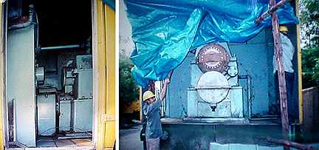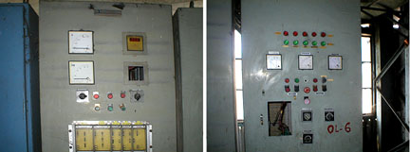

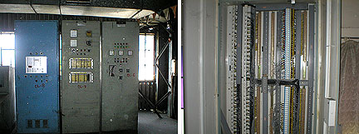

Details of Accessories

- 13.5mw Ge Frame 5 Of GE USA Make
- Generator Set Matching With The Above Gas Turbine Of Gae Alstom Make Series 5001
- C02 Compartment
- Air Filter
- Marshalling Rack
- Auto Voltage Regulator Panel
- Metering And Relay Panel
- Plc Panel
- Control Cabinets And Monitor
- Gn 4010/Metal Clader
- Air Filter Duct Big & Small
- Fuel Filter Skid

