 | CFAS Enterprises Inc.  After Market Utility Power Equipment Brokerage  Mailto:Staff@CFASPower.com  Turbine URL: http://CFASPower.com/  Reciprocating URL: http://CFASPower.com/Recips.html
GTG_1193RPE_ABB_Genends.doc

Our Ref: AL-05
Available Twelve Complete ABB Alternators, Brand New ~ Never Installed
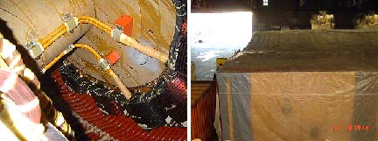
They had been well preserved according to manufacturers recommendations.
These alternators were designed for marine use in power generation application. Designed to run at 514 rpm, 11000 v, 60 HZ (to note that they can run at reduced speed 428 rpm with 50 hz application but in lower rating), with an air to water-cooling system. The technical data are available at request; meanwhile some details is as follows:

Euro 250,000 each (9720 kVA)
Euro 215,000 each (6950 kVA)
Generator (8) quantity
Manufacturer: ABB type
Model# HSG 1250-PP14.
KW: 9270Kva /7416Kw.
Voltage: 11.000V
Cycle: 60HZ
Generator (4) quantity
Manufacturer: ABB type
Model# HSG 1120-LS10.
KW: 6950kva
Voltage: 11.000V
Cycle: 60HZ
They are ready in Europe for immediate delivery, inspection at storage facilities can be arranged up on request,
They can be purchased individually or as many as you require can be arranged with payment facilities.

