 | CFAS Enterprises Inc.  After Market Utility Power Equipment Brokerage  Mailto:Staff@CFASPower.com  Turbine URL: http://CFASPower.com/Index.html  Reciprocating URL: http://CFASPower.com/Recips.html
GTG_1237TD_Viking_KG2-3C.doc

4 X Refurbish & Upgraded Viking KG2-3C 1470 KW Gas Turbines DF/60Hz Plant

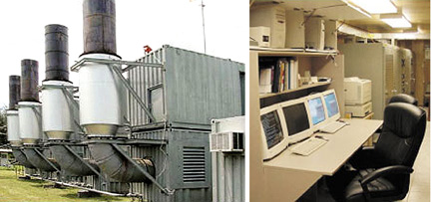

The heart of the peaking power plant is the Viking Gas Turbines, one model KG2-3C and three model KG2-3A machines currently upgraded to KG2-3C technology and firing status. These radial flow gas turbines with Ideal generators were originally designed as emergency standby generators. These four gas turbine generators have been inspected, repaired and upgraded to allow for continued operation at higher firing temperatures. These units are constructed into a modular peaking power plant totaling 5-6.5 megawatts, depending on the site conditions. The only requirements for the site is the access of power lines, access of fuel and a water supply to feed the inlet air water fogging system .
The site consists of four turbine containers and inlet containers, an electrical services container and a control room container.

Asking Price: USD $2,415,000
Hours: Total Hours150Hrs “0” Since Refurbished and Upgraded

Download Complete Data Files

- KG2-3C Basic Data-Sheet
- Overall Layout Data-Sheet
- Viking Inspection Report
- Generator Container
- Control Room Data-Sheet
- KG-2 Noise Data-Un-attenuated/Attenuated
- Electrical Services Container Data-Sheet
- Air Inlet Filter House Data-Sheet
- Air Storage Skid Data-Sheet
- Exhaust Heat Recovery Data-Sheet
- Performance Data-Sheet
- CO vs Output - Nat Gas_ DO No. 2 Data-Sheet
- NOX vs Output-NG-DO No. 2 Data-Sheet
- Hydro-Carbons vs Output-No 2_NG Data-Sheet
- Particulate vs Output-NG_No. 2 DO Data-Sheet
- Ideal Electric-Generator Design Data-Sheet

