 | CFAS Enterprises Inc.  After Market Utility Power Equipment Brokerage  Mailto:Staff@CFASPower.com  Turbine URL: http://CFASPower.com/Inventory.html  Reciprocating URL: http://CFASPower.com/Recips.html
GTG_1294JM_ W191.doc

1 x Used Westinghouse W191 16.2MW Nat Gas Turbine Plant

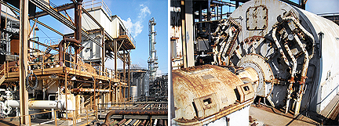

Westinghouse: W191 Gas Turbine
Excellent Condition/Indoor Installation
S/N: 171732-1
Manufactured: Late 1960s
Rebuilt With All Updates: 1991
Fuel: Natural Gas
Rated: 16,200 Kw
Laburdi Modification
Liburdi Cooling And A Catalytic Converter
Gas Turbine Shaft Speed: 4,912 RPM
Generator Shaft Speed: 900 RPM
Located: Texas
Usage;: Base Load Power
Decommissioned: 2006
Total Hours: 87,000

Shut Down For Inspection In 1997 And All Repairs Were Made
All Of All Inspections And Maintenance Available

Gear Box To Mate With Generator

Generator
Rating: 16,320 KW/19,200 KVA
Frequency: 60hz-Can Be Made 50Hz
Volts; 13,800 Volts
Speed: 900 RPM
Power Factor: 85%
803 Amps 125 Exciting Volts
Direct Current Exciter Rating: 80 KW
Starter Engine: 435 HP Allis Chalmbers

Price: $ 925,000.00

