 | CFAS Enterprises Inc.  After Market Utility Power Equipment Brokerage  Mailto:Staff@CFASPower.com  Turbine URL: http://CFASPower.com/Inventory.html  Reciprocating URL: http://CFASPower.com/Recips.html
GTG_1390BK_EvapCooler.doc

Two (2) Unused Donaldson Evaporative Coolers

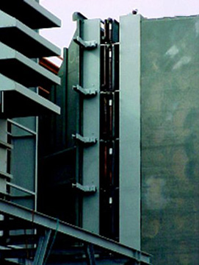

Asking US $165,000 each
Ex-works: Antioch, California
Subject to prior sale.

Unused, never installed.
These units provide clean cooled air to the engine and were to be used with
GE Frame 7FA gas turbine units (approx. 180 MW's each) and could be adapted
for a number of different turbine engine units.

Benefits:

- Increases power and reduces power dips.
- Economical to operate.

Design:

- Uncomplicated modular design providing easier installation and requires very
little field welding.
- Structural design is expected to be leak-free for the life of the unit.

Hazard Protection:

- No water carryover
- Low air pressure drop of max. 10mm water gauge
- No loose fasteners downstream of the final filtration stage.
- Excellent corrosion protection.

