 | CFAS Enterprises Inc.  After Market Utility Power Equipment Brokerage  Mailto:Staff@CFASPower.com  Turbine URL: http://CFASPower.com/Index.html  Reciprocating URL: http://CFASPower.com/Recips.html
GTG_1429JL_LM2500Genend.doc

1 x Used Holec Ridderkerk 24Mw LM2500 50Hz Generator

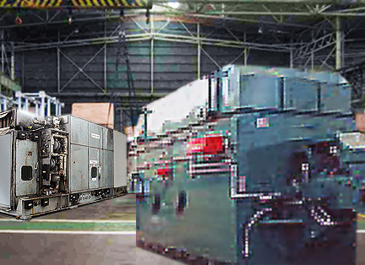
Photo Exemplar

Asking Price: USD $435,000

- Unit Is In Dry Storage In Holland.

Generator

- Holec Ridderkerk: Dutch Manufactured
- Type Generator: DTG 177ZM-02
- Type exciter: DTGBP 45/20
- Rated Output: 30000 KVA, 24000kW
- Power Factor: 0.8
- Voltage: 10500 V
- Frequency: 50Hz
- Speed: 3000 rpm
- Date of Manufacturing: 17-02-1991

Estimated hours on the clock: 80.000

