 | CFAS Enterprises Inc.  After Market Utility Power Equipment Brokerage  Mailto:Staff@CFASPower.com  Turbine URL: http://CFASPower.com/  Reciprocating URL: http://CFASPower.com/Recips.html
GTG_1477KP_Rentech_HRSG.doc

One (1) unused Rentech Heat Recovery Boiler complete with SCR and Duct Firing

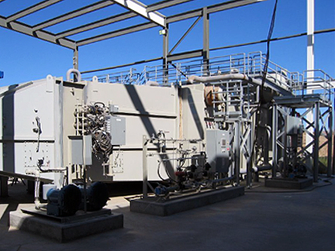

Asking US $600,000
New cost was approximately $1.35M

Steam Conditions

Steam Pressure: 360 psig
Steam temperature: 553°F
Fired Steam Flow Up To: 54,000 lbs/hr
F.W. Temperature: 228°F.

HRSG Design Pressures

Evaporator: 460 psig
Economizer: 510 psig
FW Preheater: 200 psig

HRSG Furnished By Rentech Will Be Equipped As Follows

Inlet Duct
Duct Burner
Combustion Chamber
Evaporator (module #1)
Evaporator (Module #2) With Steam Drum
Economizer
SCR System
CO/VOC Catalyst System
Exhaust Stack
Exhaust Stack Access Ladder/Platform
Platforms, Ladders, And Walkways

