 | CFAS Enterprises Inc.  After Market Utility Power Equipment Brokerage  Mailto:Staff@CFASPower.com  Turbine URL: http://CFASPower.com/Index.html  Reciprocating URL: http://CFASPower.com/Recips.html
GTG_1529SC_GELM1600_50Hz.doc

1 x 1991, GE, 7LM1600-GA-ND 13500KW 11000V 50HZ DF CHP Power Plant

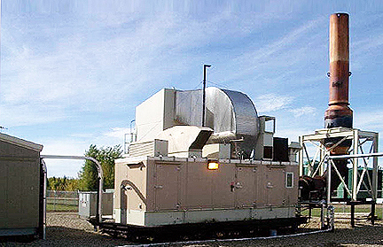

Asking Price: $3.15 MM
GAS TURBINE:
Turbine Manufacturer: GE
Turbine Model: 7LM1600-GA-ND
Year Manufactured: 1991
ISO Base Rating: 13,500 kW
Heat rate: 10394 kJ/kWh (LHV)
Fuel Type: Nat Gas/Liquid
Fuel Consumption: Diesel) - 964 GPH @ 138, 000 p/g
Nat Gas - 128,133 Cubic Feet/Hr at 1038 BTU per Standard Cubic Foot.
Efficiency %: 35%
Operating Hours: 48,000 Approx
Maintenance: Long Term Contract
POWER TURBINE:
Manufacture: Ruston Gas Turbine Ltd
P.T. Type: ELM116/2
Year of Manufacture: 1991
Operating Hours: 19,000 Approx
GEARBOX:
Manufacturer: Allen Gears
G/Box Type: Epicyclic
Gear Ratio: 4,666;1
Power Rating: 10,600 kW
GENERATOR;
Manufacturer: Brush
Model: BSGMD 118.240/4
Power Output: 16,232 kVA
Voltage: 11,000 Volts
Amps: 852
Frequency: 50 Hz
Power Factor: 0.85
GAS COMPRESSOR:
Manufacturer: Belliss & Morcom
Type: WH5-X-1003N
Discharge Pressure: 39 bar g
Speed: 745 rpm
Drive Motors; Bush 325 kW
RPM: 746
WASTE HEAT RECOVERY BOILER:
Manufacturer: ME Boilers
Date of Manufacture: 1991
Design Code: BS 1113 1989
Design Pressure: 25 bar g
Design Metal Temperature: 250 degree C
Test pressure: 31.25 bar g at ambient deg C
Total Weigh Empty: 52 tonne

