 | CFAS Enterprises Inc.  After Market Utility Power Equipment Brokerage  Mailto:Staff@CFASPower.com  Turbine URL: http://CFASPower.com/Index.html  Reciprocating URL: http://CFASPower.com/Recips.html
GTG_1534LF_GEFm5LA_60Hz.doc

1 x Used GE F5LA 16Mw 60Hz DF Gas Turbine Generator

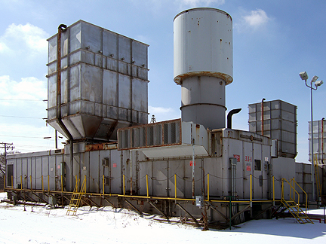

Asking Price and term of sale: $500,000 ex-site New York, USA

Gas Turbine

Manufacturer: GE
Quantity: 1
Year Manufactured: 1969
Serial #: 214004
Model: LA
Current Site Capacity: 16,165 kw
Grquency: 60Hz
Fuel: Gas/#2 Oil

Scope Of Supply included in sale – Cummins Diesel Start (relatively new), Cutler Hammer Excitation sys, Oil lube sys, fuel oil heating & fwding sys, air intake housing (screen & connecting ducts), exhaust stack w/ baffles, sections of switchgear w/ breaker section, overhead bus duct, outdoor housed cabinet w/ step down excitation transformer (12.6KV primary, 240V secondary)Westinghouse Ovation control sys, (3) cabinets, indoor cabinet of switchgear w/ metering section (power cabinet), Worthington (Model 0F6-2) Nat gas compressor & related dwgs, operation, maintenance & instruction manuals

Number Of Hours Since LMO: 590
Number Of Starts Since LMO: 52
Control System: Westinghouse Ovation

Generator

Generator Manufacturer: GE
Serial Mo.: 8384366
Model: ATB-2
Nominal Power: 21,176 KVA, 886 amp
Nominal Voltage: 12.6 KV
Nominal speed: 3600 rpm gearbox

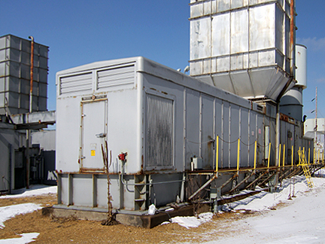

General information:

Cooling – Air
Boroscope Inspection provided upon request
Availability date for removal from site – Immediate
Last major – 2001
Turbines last operated – 2003
Auxillary Equipment included – gas compressor
Current Location – New York
Last Gen rewind – 1991
2nd Stage is Tie Wire

