 | CFAS Enterprises Inc.  After Market Utility Power Equipment Brokerage  Mailto:Staff@CFASPower.com  Turbine URL: http://CFASPower.com/Index.html  Reciprocating URL: http://CFASPower.com/Recips.html
GTG_1547RC_GEC_Genend.doc

One (1) 26,075KVA, 20,000KW, GEC Alsthom Synchronous Generator
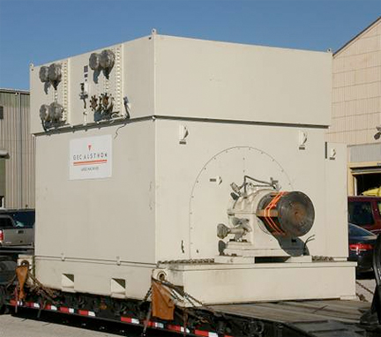
Asking Price: US $495,000.00 ExWorks
Available for service
Download Report

Frame AG183M131, S/N: L21207601, 3 phase, 60 hz,13.8kv, 1800 RPM, 4 pole, 0.9 leg Power Factor, Rated line current 1091 amps, Nema MG-1, enclosure IP 44 totally enclosed, cooling IC8A1W7 water cooled. Equipped with exciter and rectifier, bearing pedestal with coupling all on common base. Year of manufacturer 1995.

Approximate Dimensions: 20' - 0”L x 13 - 6"W x 11' - 2"H
Approximate Weight: 40,000 kg - 117,000 lbs

