 | CFAS Enterprises Inc.  After Market Utility Power Equipment Brokerage  Mailto:Staff@CFASPower.com  Turbine URL: http://CFASPower.com/Index.html  Reciprocating URL: http://CFASPower.com/Recips.html
GTG_1548RC_Kato_Genend.doc

1 New/Unused Kato 5700KW 6706KVA AC Synchronous Generator

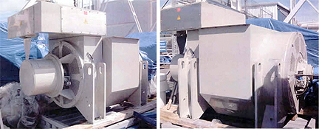

Asking Price: US $345,000.00

Qty. 1 New/unused 5700KW, 6706KVA Kato AC synchronous generator, Model AA28154000; code 4P10.7-3600; S/N: 20683-06; 3 phase, 50 hz, 7621/13,200V, 1500 RPM; .85 P.F.; 6 wire, 293 amp; 130 deg C rise; 15 deg. C ambient; Class “F” Insulation; Sequence T1,T2,T3, CCWFDE rotation; ODP enclosure. Exciter: Field amps: 5.1; Field volts: 100; PMG volts: 200; PMG hz.: 150

Alternative ratings:
60 hz. “F” rise, 12,470-13,800V; 6300KW/7875KVA; 0.8 P.F., 1800RPM
60 hz. “B” rise, 12,470V; 5600KW/7000KVA; 0.8 P.F., 1800RPM
50 hz. “B rise, 11,000V; 4700KW/5875KVA; 0.8 P.F., 1500RPM
Built: 2008
Off Solar gas turbine application
Approximate dimensions: L-10’-8” x W-5’-8” x H-6’-1”
Approximate weight: 28,200 lbs

