 | CFAS Enterprises Inc.  After Market Utility Power Equipment Brokerage  Mailto:Staff@CFASPower.com  Turbine URL: http://CFASPower.com
GTG_1553SC_Mars_60Hz.doc

1 x Used Solar Mars 100 10.695KW 4160V 60HZ Nat Gas CHP Plant

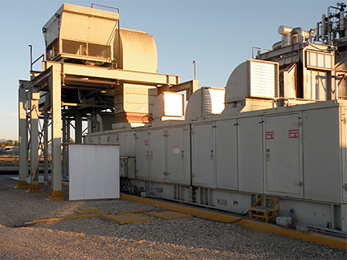

Asking Price: US $2,275,000
Reports Available on Request
Mars 90 Upgraded to Mars 100

GAS TURBINE:
Manufacturer: Solar
Model: Mars 90->MARS 100 Upgrade
Fuel: Natural Gas
Rating: 11885 hp
Kw: 10.695KW
Speed: 10780 rpm
Generator:
Manufacturer: Ideal Electric
Rating: 7640 kw
Kva: 9550 kva
Voltage: 4160 v
Phase: 3
Frequency: 60 hz
Speed: 1800 rpm
PF: 0.8
HRSG:
Manufacturer: Struthers Industries Inc
Rating: 43,500 lbs/hr
SCR:
Manufacture: W.R. Grace
Control: Turbotronics I
HISTORY:
Year built: 1989
Last Major Overhaul: April 10, 2004
Life time package hours: 67,581
Life time package starts: 1926
Hours since last overhaul: 1221
Starts since last overhaul: 125
Unit is still installed

