 | CFAS Enterprises Inc.  After Market Utility Power Equipment Brokerage  Mailto:Staff@CFASPower.com  Turbine URL: http://CFASPower.com/Index.html  Reciprocating URL: http://CFASPower.com/Recips.html
GTG_1631TGD_LM1600_50Hz.doc

1 x Used LM1600 12MW 50Hz Natural Gas Plus BOP Power Plant

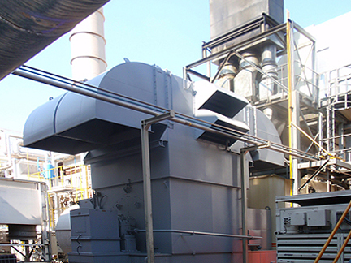

Asking Price: US $3.21 MM plus shipping.
Plant has been disassembled and repackaged
US $500,000.00 in new spares and controls.

Download Complete Scope Of Supply

Turbine
Number of Units: 1
Manufacturer: G.E
Type: Lm1600
Base Load: 12MW
Peak Load: 14.5MW
Load rate 12MW
Comp Stages: G.E
Turbine Stages: G.E
Turbine speed: EGT1500RV
Exhaust temp base: 500°C
Exhaust temp peak: 550°C
Fuel type: GAS
Manufacturing Date: 1992
Total hours: 123,446 hr
Hours Since OH: 1000-3000hrs

Gearbox
Manufacturer: GEC A.L.M/C
Type: HSG 71 OH
Kw: 14620
Speed: 6414
Oil: ISOA/G46
Manufacturing date: 1992

Generator
Manufacturer: GEC ALSTOM
Type: SYNCRONO DE CA
Cooling: AIR
KVA: 16133KW
Frequency: 50HZ
Speed: 1500RPM
Voltage: 6300V
Insulation class: IP43
Current: 1478A
Phase: 3
Poles: 4
Manufacturing date: 1992
Power factor: 0.8

Exciter
Type: SIN ESCOBILLAS

Control
Type: RUSTRONIC

Start System
Device: ABB
Type: MOTOR HYDRAULICO

Offer Included
LM1600 Gas Turbine Generator
Gas compressors
Medium voltage switchgear,

