 | CFAS Enterprises Inc.  After Market Utility Power Equipment Brokerage  Mailto:Staff@CFASPower.com  Turbine URL: http://CFASPower.com
GTG_1700SC_Mars100_50Hz.doc

3 x Unused 2009 Solar Mars 100 8.8MW 11KV 50HZ Nat Gas Generator Plants

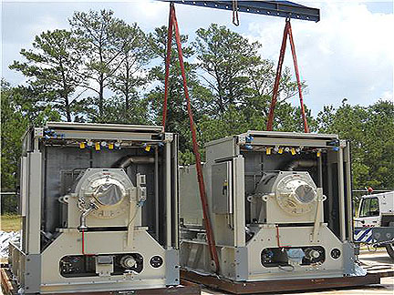

Units are immediately available and can be converted to 60Hz
Asking Price: US $4.7MM Each – Negotiable

Manufacturer: Solar
Model: Mars 100 Gas Turbine
Rating: 8,800KW/11,000KVA
Phase: 3PH
Frequency: 50Hz
Voltage: 11,000V
Qty: 3
Condition: Unused
Year Manufactured: 2009
Fuel: Natural Gas
Fuel input: 79.3 MMBtu/hr
Exhaust Temp: 905°F
Exhaust Mass Flow: 337.9 thousand lbs/hr

Included:
Control System
Starting System
Fuel System
Skidded with Weatherproof and Sound Attenuating Enclosure
All auxiliary equipment for complete operation

