 | CFAS Enterprises Inc.  After Market Utility Power Equipment Brokerage  Mailto:Staff@CFASPower.com  Turbine URL: http://CFASPower.com/Index.html  Reciprocating URL: http://CFASPower.com/Recips.html
GTG_1705RH_GEFM5R_60Hz.doc

1 x Refurbished GE FRAME 5 Model MS5001 60HZ DF Generator

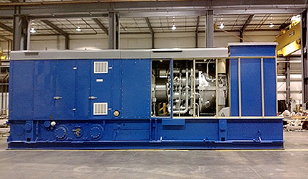

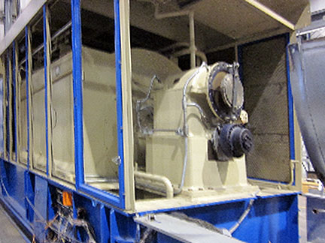

Asking Price: $3.4 MM
Warrantee: 18 month warranty

Manufacturer: GE
Model: Fm5R
Rating: 17,700KW
Frequency: 60hz
Voltage: 12.4V can be worked back up to 13.8V
Generator: 18,824KVA 3600RPM 12,470V, 0.85PF, 60Hz
Gear Make And Type: GE type S-524-Form A4-19600KW 5105/3600RPM
Controls; All new controls by Allen Bradley
Fuel: Dual fuel (Liquid and natural gas)
Condition: ZERO HOUR OH Refurbished sound attenuated package

