 | CFAS Enterprises Inc.  After Market Utility Power Equipment Brokerage  Mailto:Staff@CFASPower.com  Turbine URL: http://CFASPower.com/Index.html  Reciprocating URL: http://CFASPower.com/Recips.html
GTG_1716NI_SatT1501_60Hz.doc

1 x Used Turbine, Solar Saturn, T1501, Generator Set

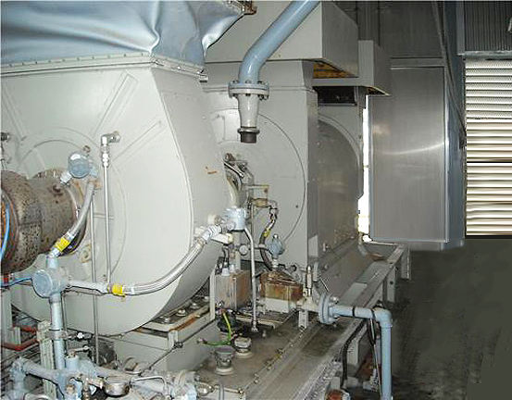

Asking Price: US $175,000

Manufacturer: Solar
Model: T1501
Alternator: Kato
Rating: 1100kW, 1375kVA
Voltage: 277/480V
Speed: 1800rpm
Fuel: Natural Gas
Year Manufactured: 1993
Hours: Approx. 22,000hrs
Qty: 1
Skid Mounted
Status: Removed Lafayette, LA.

Included: Oil Cooler & Control Panel

