 | CFAS Enterprises Inc.  After Market Utility Power Equipment Brokerage  Mailto:Staff@CFASPower.com  Turbine URL: http://CFASPower.com/Inventory.html  Reciprocating URL: http://CFASPower.com/Recips.html
GTG_1741GLE_MarsCC_50HZ.doc

1 x 2008 Solar Mars Combined Cycle 12.7Mw 50Hz Power Plant

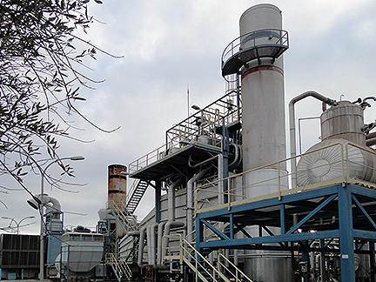

PRICING
Completed Plant: 625.000€
Gas Turbine: 425.000€
Including: Generator, Container, Controls, Cooling & Oil Systems

Completed CC Plant
Rating: 12,7 Mw
YOM: 1998

Gas Turbine
Model: Solar Mars.
Rating: 9,8 Mw
Total Hours: 30.000
Main Overhaul: 2004.

Steam Turbine
Model: KKK-PASCH
Rating: 2,9Mw
Total Hours: 30.000.

Steam Generator
Foster Wheeler
Cooling system

INCLUDED
Transformers 6,3Kv step up 20Kv
Switch breakers
Air system
Water treatment system

