 | CFAS Enterprises Inc.  After Market Utility Power Equipment Brokerage  Mailto:Staff@CFASPower.com  Turbine URL: http://CFASPower.com/Index.html  Reciprocating URL: http://CFASPower.com/Recips.html
GTG_GTG_1743ES_FM5001_60Hz.doc

4 x Low Hour GE MS5001N, 60Hz DF Packaged Generating Plants

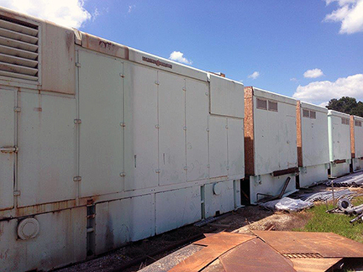

Plant Rating: 100 MW Power Block
Manufacturer: GE
GE "LYNN" AIR COOLED
Model: MS5001N
Rating Each: 19.55 MW
RPM: 3600
Hz 60
Power Factor 0.85
kW 23,000 KVA
Amps 962
Volts 13,800
Fuel: Duel Fuel (Light Distillate Fuel)
YOM 1970
No. of Units: 5
Condition: Used
Hours: AVG-13,000 - 15,000
Starts: AVG- 4,000
Utility Owned

**Will Require 1 x 200Kw Black Start Generator

The units were taken off line in 2014. They were properly shut down and
preserved. The last maintenance was preformed in 2014 as well.

Weights and Dimensions

Approximate Weights
Gas turbine: 70,000 Lbs
Turbine base and piping: 68,000 Lbs
Starting means and accessory gear: 20,700 Lbs

Dimensions
Overall Length: 39 Meters
Width: 3.2 Meters
Height: 3.8 Meter

Asking Price $300,000 each.

