 | CFAS Enterprises Inc.  After Market Utility Power Equipment Brokerage  Mailto:Staff@CFASPower.com  Turbine URL: http://CFASPower.com/Index.html  Reciprocating URL: http://CFASPower.com/Recips.html
GTG_1745CDFV_FiatTG16_60Hz.doc

1 x Complete W191/TG16 15.6Mw 60Hz Nat Gas Turbine Generator Package

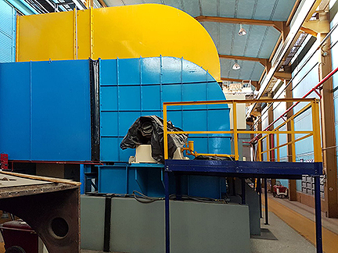

Gas Turbine: Westinghouse/Fiat 191/TG16
Generator: English-Electric
Serial No.: 1412/214
Specs: ASA.C.50
Speed: 1800 RPM
AMPS: 768 Amps
Frequency: 60 Hz
Phase: 3
KW: 15,600
Voltage: 18,370
Insulation: 8
Power Factor: 0.85
Exciter Voltage: 56 V
Capacitor Output
Sub-Excitation: 9300 MVAR
Over-excited: 14700 MVAR
OHM Resistence
Strator: 0.03005 OHMS/Phase at 18.5 Grad.Centegrade
Rotor
Max Temp:
Strator: 120°C A 26°C Ambient Temp.
Rotor: 130°C A 26°C Ambient Temp.
Cap: Parallel

Stopped Operating: 2014
Hours since last OH: 5,941hrs
Starts: 372

Complete w/Turbine, Generator, control room, Transformer and all auxiliary equipment except fire prevention system

Asking Price: $450.000

