 | CFAS Enterprises Inc.  After Market Utility Power Equipment Brokerage  Mailto:Staff@CFASPower.com  Turbine URL: http://CFASPower.com/  Reciprocating URL: http://CFASPower.com/Recips.html
GTG_174EP_SGT400Mobiles_60Hz.doc

3 x New Siemens SGT400 12.9 MW 60Hz (DF) Gas Turbine Mobile Generator Set

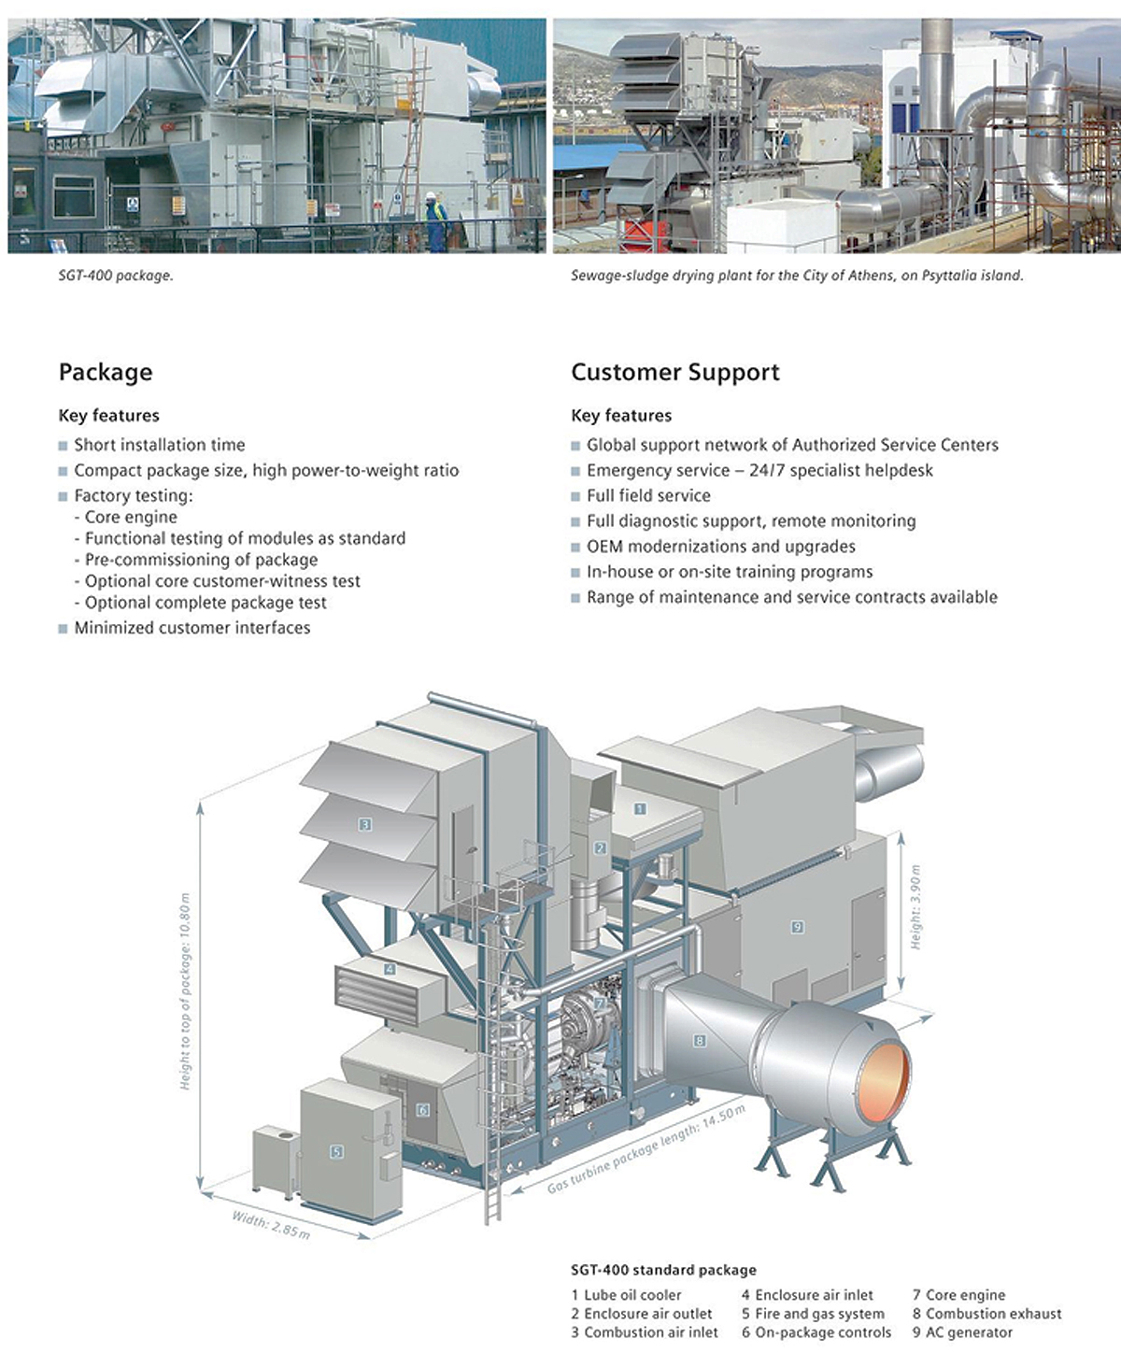

Download Pdf (Large Document-May Take Some Time)

See Page 44 – 47 of Pdf for main specs and photos

1. Scope of Supply
Siemens Industrial Turbomachinery Ltd hereinafter “Siemens” offer to design,manufacture, package and despatch the following equipment listed within this scope of supply.

1 x SGT400 gas turbine mobile generator package, comprising :

1.1 Driven Unit

1.1.1 Generator
• AC Generator, 13.8kV, 3 phase, 4 pole, 50 / 60Hz, 0.8 power factor, salient pole brushless type
• Other ratings may be available on request
• Closed air circuit air cooled ( CACA )
• Class ‘F’ insulation with class ‘B’ total temperature rise
• Generator bearing temperature detectors
• Lubricating oil piping from gas turbine to driven unit
• Pfisterer MV connectors

1.2 Gas Turbine Package

1.2.1 Gas Turbine Engine
• Core Engine – twin shaft design
• Gas Generator
• Air Inlet Casing
• Compressor Rotor
• Compressor Stator with Variable Guide Vanes
• Centre casing
• Dual Fuel Combustion System – Dry Low Emissions (DLE)
• Compressor Turbine Rotor
• Compressor Turbine Stator
• Power Turbine
• Hot Gas Interduct
• Power Turbine Rotor
• Power Turbine Stator
• Output Shaft Drive
• Exhaust Outlet Casing
• Engine Bearing Temperature Instrumentation
• Engine Vibration Instrumentation
• Engine arranged for hot end drive

1.2.2 Underbase
• Turbine underbase – fabricated carbon steel construction, arranged for multi-point mounting
• Integral lubricating oil tank – carbon steel
• Generator and gearbox underbase – fabricated carbon steel construction, arranged for multi-point
mounting
• Support legs – underbase to ground, fixed on installation to carry all static and dynamic loads

1.2.3 Trailers
• 3 Axle gooseneck trailer for mounting of:
• Gas turbine package
• Lube oil cooler
• Fire extinguishant cabinet
• Water wash module
• 5 Axle gooseneck trailer for mounting of:
• Generator
• Gearbox

1.2.4 Start System
• Hydraulic Motor and Pump - AC electric motor driven

1.2.5 Gears, Couplings and Guards
• Main speed reducing gearbox – epicyclic type, output shaft speed 1500 / 1800 rpm
• Acoustic Enclosure – painted carbon steel, fitted over the gearbox
• Doors for personnel access
• Internal lighting
• Natural Ventilation
• Auxiliary gearbox incorporating drives for start system and lubricating oil pump
• Generator and Gearbox, seismic vibration monitoring - Bently Nevada 1701 system
• Drive coupling – high speed - flexible element dry type – Turbine to gearbox
• Drive coupling – low speed - flexible element dry type – Gearbox to generator
• Coupling guard – high speed (brass) – Turbine to gearbox
• Coupling guard – low speed (brass) – Gearbox to driven unit

1.2.6 Lubricating Oil System
• Gas turbine lubrication system utilises mineral oil
• Lubricating Oil System serving the turbine, gearbox and driven unit
• Lubricating Oil Pump Main – Turbine gearbox driven
• Lubricating Oil Pump Auxiliary – AC motor driven
• Lubricating Oil Pump Emergency – DC motor driven
• Lubricating oil system filter
• Duplex filter arrangement
• Continuous flow transfer valves
• Conforms to API 614
• Filter body carbon steel
• Differential pressure indicator
• Lub oil module transmitters – Siemens standard smart type - aluminium
• Lubricating oil tank immersion heater
• Lubricating oil system breather
• Lubricating oil breather oil mist eliminator
• Lubricating oil breather ducting – austenitic stainless steel
• Lubricating oil system cooler
• Airblast Simplex Lubricating Oil Cooler – non API
• Cooler Fan – single 100% duty
• Suitable for a non-hazardous area
• Lubricating oil cooler piping supply and return – austenitic stainless steel

1.2.7 Gas Fuel System
• Pilot fuel flow control system with actuator
• Main fuel flow control system with actuator
• Rapid-acting gas shut-off valves ( 2-off )
• Pressure transmitters - Siemens standard smart type - aluminium
• Gas fuel block and vent valve assembly - off package

1.2.8 Liquid Fuel System
• Liquid fuel pump, AC motor driven – Zone 2 motor
• High pressure fuel filter
• Fuel flow control valve
• Liquid fuel purge system
• Pressure transmitters – Siemens standard smart type - aluminium
• Block and thermal relief valves – Siemens standard – off package

1.2.9 Acoustic Enclosure
• Acoustic Enclosure – painted carbon steel, fitted over gas turbine and auxiliaries
• Doors for personnel access and maintenance
• Integral lifting beam for maintenance
• Internal lighting
• Acoustic system transmitters - Siemens standard smart type – aluminium
• Controls Weather Protection Canopy - Aluminium
• DU Controls Weather Protection Canopy - Aluminium

1.2.10 Acoustic Enclosure Ventilation System
• Ventilation air inlet filter – inertial type – carbon steel galvanized
• Ventilation inlet and outlet dampers – carbon steel galvanized – air release operated
• Ventilation fan – single – AC electric motor driven – Zone 2
• Ventilation air system – negative pressure
• Ventilation air silencer – carbon steel galvanized
• Ventilation air inlet and outlet ducting – carbon steel galvanized
• Integral support for turbine enclosure ventilation system

1.2.11 Gas Detection System
• Gas Detection equipment, comprising :-
• 2 - Gas Detectors (vent outlet)

1.2.12 Fire Protection System
• Fire Protection equipment, comprising :-
• 3 - IR Flame Detectors
• 2 - Heat Detectors
• Single Sounder
• Status Indicator (end of package)
• Single MAC (Manual Alarm Contact)
• Breakglass Unit

1.2.13 Combustion Air Inlet System
• Combustion air filter – automatic pulse type, self cleaning – horizontal elements - painted carbon steel
• Combustion air filter weather hood
• Combustion air silencer – painted carbon steel
• Combustion air inlet ducting – painted carbon steel
• Integral support for combustion air inlet system

1.2.14 Combustion Exhaust System
• Exhaust diffuser – 304 stainless steel
• Exhaust silencer – 304 stainless steel
• Exhaust stack – 304 stainless steel – vertical orientation
• Thermal insulation and aluminium cladding – personnel protection only

1.2.15 Local Equipment Room
• Container (12.2m Long x 3.0m wide x 3.2m High) of carbon steel construction
• External walls of corrugated carbon steel sheet
• Internal rockwool insulation
• containing the following equipment:
• Motor Control Centre – for package motors
• Fire Suppression and Alarm Panel – including extinguishant bottle
• Battery Cabinet
• Batteries - lead acid type, sized to ensure a safe rundown of the turbine and driven unit in an emergency
• Battery Tripping Unit and Batteries
• Inter Panel Cabling
• Auxiliary Transformer
• Medium Voltage Switchgear
• Neutral Earthing Resistor
• Main Control Room Dual Incomer Distribution Board
• Auxiliary Control Panel
• Power and Lighting Distribution Board and Transformer
• Diesel Generator for LER power distribution
• GPS Enclosure/Junction Box
• Fibre Optic Panel
• LV Connector Junction Boxes
• Elliott Bushings for feeders
• Pfisterer MV connectors for generator incomer and NER

1.2.16 Package Auxiliaries
• Turbine compressor cleaning system for on line and off line wash
• Drains Tank on package
• Auxiliary module transmitters Siemens standard smart type – aluminium
• Instrument tagging – Arrow tags - Siemens standard P&ID references
• Package finish to Siemens onshore standard
• Access steps to trailer

1.2.17 Cabling
• Site plug and socket interconnecting cables between Siemens equipment

1.3 Control System

1.3.1 Package Control System Hardware
• Unit Control System – simplex, incorporating a Siemens SIMATIC PLC platform
• Control and monitoring of the package systems
• Control system located on-package
• Climate control incorporated
• Emergency stop function – on-package control panel mounted
• Operator display language in English
• Turbine Vibration displacement monitoring - Bently Nevada 1701 system
• Remote cabinet mounted PC, VDU, keyboard and mouse
• Generator Control Panel ( Safe Area ), package mounted, containing :-
• Automatic voltage regulator (Dual Redundant)
• Synchronising facility – automatic & manual with check synchroniser
• Generator metering equipment and electrical protection
• Active / Reactive Load Share Controller

1.3.2 Siemens Turbomachinery Applications – Remote Monitoring System – STA-RMSTM
• Provision for data collection and remote communication from site allowing access to the following
services:
• Connection via broadband internet connection (customer supply)
• Automatic recording of data values within the Control System
• Analysis of events
• Analysis of downtime
• Predictive trending
• Anomaly detection
• Software updates
• Accelerated troubleshooting support
• Customer notification reports
• Access to historic data
• Fleet and unit performance overview
• Driven unit monitoring

1.4 Testing

1.4.1 Testing Gas Turbine
• Gas turbine frame and systems test (completed)
• Gas turbine core engine test (completed)
• Emissions test during gas turbine core engine test (completed)
• Site verification test in accordance with Siemens test procedure TSP00174A

1.4.2 Driven Unit Test
• Manufacturer’s standard works acceptance test of AC Generator
1.5 Installation and Maintenance
1.5.1 Installation and Commissioning
• Supervision of installation and commissioning is offered on a daily rate basis

Siemens Industrial Turbomachinery Ltd
Revision 1

1.5.2 Installation and Maintenance Equipment
• Roll-off equipment - Gas Turbine power turbine
• Roll-off trolley – Gas Turbine core engine removal (1 off total)
• ‘A’ Frame Gantry (1 off total)
• Installation Tools (1 off total)
• Holding down fixings
• Selection of paints for site repairs

1.6 Drawings and Documentation
• Standard set of certified information and approval drawings in the English language
• Operator Manual – In English language - CD
• Maintenance Manual – In English language - CD
• Illustrated Parts Catalogue – In English language - CD
• Driven Unit Manual – In English language - CD

1.7 Packing and Delivery

1.7.1 Packing
• Packing and preservation to suit destination and transport method

1.7.2 Standard Delivery Terms
• Delivered Free Carrier (FCA), in accordance with ICC INCOTERMS 2000 edition

1.8 Spares

1.8.1 Commissioning Equipment and Tools
• Commissioning equipment and tools

1.8.2 Commissioning Spares
• Commissioning spares

1.8.3 Consumable Spares
• Consumable spares

1.9 Quality Assurance
• Contract quality assurance programme – English language

1.10 Additional Items (Optional)

1.10.1 Black Start Diesel Generator
• A 4 axle trailer mounted diesel generator package (1 off sized for 2 x SGT400) comprising:
• Diesel
• Generator
• Fuel tank
• Neutral Grounding Resistor
• Batteries
• Distrubution Panel
• Interconnecting cables to LER

1.10.2 Instrument Air Compressor
• A self contained instrument air compressor package comprising:
• Instrument Air Compressor
• Controls for local and remote operation
• Duplex filter
• Duplex dessicant drier
• Instrument air receiver
• Interconnecting cables to LER
1.10.3 Step Down Transformer
• A Step Down Transformer
• 18 MVA, 13.8 kV / 6.9 kV, 2 ± 2.5% OFLTC
• Other ratings available on request
• Delta / Delta connection
• Block differential protection

