 | CFAS Enterprises Inc.  After Market Utility Power Equipment Brokerage  Mailto:Staff@CFASPower.com  Turbine URL: http://CFASPower.com/Inventory.html  Reciprocating URL: http://CFASPower.com/Recips.html
GTG_2058NC_26500kVA.doc

Two Used 26500 kVA/21200KW/50Hz Alternators

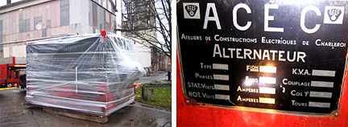

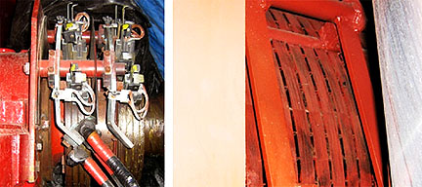

Asking Pricing: USD $ 200,000:

- Complete Alternator & Auxiliaries as stated above, delivered Ex- Warehouse, India on As Is Where Is basis:

2 Nos. –26500 kVA each, ACEC make Synchronous Alternators having the following Technical Specifications:

Year Of Manufacture: 1961 & 1972
Condition: Excellent
Status: Stored In Warehouse

2 NOS. 26500 kVA ACEC ALTERNATORS

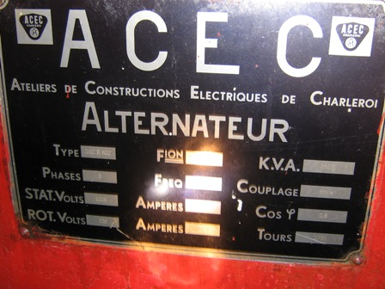
Make: ACEC Charleroi (GEC Alstom)
Year Of Manufacture: 1961 & 1972
Type: TACR 832
Capacity: 26500 kVA
Speed: 3000 RPM
Stator Voltage: 6000 V
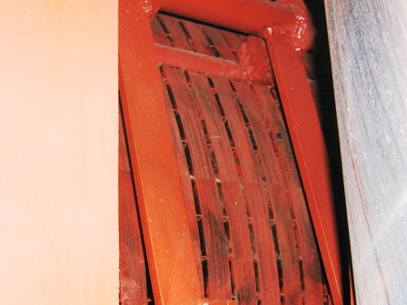
Stator Amps: 2550 A
Rotor Voltage: 230 V
Rotor Amps: 670 A
Phase: 3
Cycles: 50 Hz
PDF. : 0.80
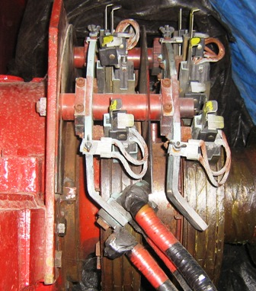
Connection: Star
FIONA: 38 GM 13968

NOTE:

- Water Cooling System And AVR Panel For The Above Alternators Are Available.

- AVR System Is Available And It Has Been Installed Recently In The Year 1995&96.

- Machines Were Generating Power Up to The Year 2000. Regular Maintenance Was Conducted To Keep The Machines In Good Condition.

- Also All Operating, Maintenance And OEM Manuals for the Alternators Are Available.

GENERAL TERMS OF BUSINESS:

Taxes/ Duties: Whatever Applicable Will Be Charged Extra.
Terms: One- Third With Order, Balance + Taxes As Applicable Before Delivery.
Delivery: Immediate, Ex – Warehouse.
Offer: Strictly Subject To Prior Sale And/Or Our Final Confirmation.

