 | CFAS Enterprises Inc.  After Market Utility Power Equipment Brokerage  Mailto:Staff@CFASPower.com  Turbine URL: http://CFASPower.com/Inventory.html  Reciprocating URL: http://CFASPower.com/Recips.html
GTG_409MDE_KAT0_GENEND_50HZ.doc_.doc

New/Unused Kato 2 Bearing 4320 Kw/50Hz/11Kv Genend Off Cat 3616

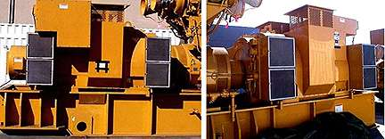

Asking Price: USD$ 40,000.00

- Model A252930002;
- Catalog No. 6P12-3600
- S/N 10818-02; Type 25293
- Skid, Cooling Module & Fuel Heater Included
- 4320 Kw Continuous
- 5400 Kva Continuous
- 6351 / 11,000 Volts
- 3 Phase
- 50 Hertz
- 1000 Rpm
- 6 Wire
- 0.8 Power Factor
- 80 Degree C Rise By 40 Degree C Ambient
- 44,250 Lbs. Shipping Weight.

FOB; At Site, USA

