 | CFAS Enterprises Inc.  After Market Utility Power Equipment Brokerage  Mailto:Staff@CFASPower.com  Turbine URL: http://CFASPower.com/Index.html  Reciprocating URL: http://CFASPower.com/Recips.html
GTG_737JS_Kaw_3MW60HZ.doc

Kawasaki M1A/13A 3MW, 60Hz CoGen w/HRSG Mobile 3MW Power Plant

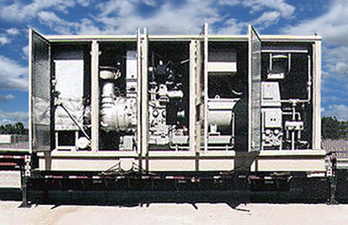

Base Asking Price:

MGU30 Co-Gen US $2,400,000
Configuration: 1 x 60’ Trailer Mounted Unit:
Rating: 3.0MW, 60hz, 30,000pph steam @ ISO
Dim: 10ft W X 60ft L X 13’-6” H
Shipping weight: 165,000lb
Includes 1yr/8000 Hr. warranty

PGU30 Power Package: US $1,800,000
Configuration: 2 Mod Trailer Mounted Unit
Includes 1yr/8000 Hr. warranty

Options Prices
Liquid Fuel: $160,000
Propane (LP) conversion: $110,000
Steam Injection system: $160,000
Control system for Islanding: $45,000
Inlet Cooling: $190,000
Inlet Cleaning Filter: $45,000
50Hz Conversion: $225k. 8 weeks lead time

1 Year warrantee

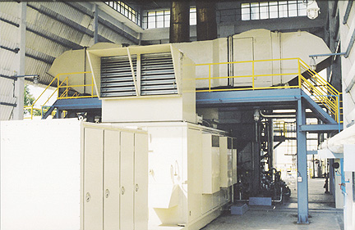

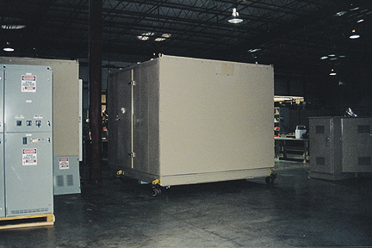

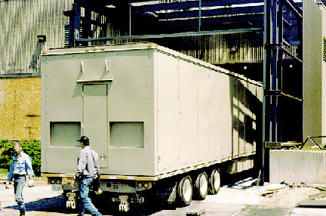

Power Generation

Packages readily available are 3MW cogen trailer mounted systems consisting of 2 x power generation units (PGU). Mobile cogen package is MCU.

The PGU series also offers a convincing number of advantages over reciprocating engines including: ¼th the weight, 1/7th the size, ½ the maintenance cost, lower noise, higher reliability, greater fuel flexibility, and less than one half the total machine parts for maintenance and parts storage. Most importantly, the PGU series produces cleaner exhaust emissions compared to reciprocating engines operating on No. 2 fuel oil. Natural gas operating emissions are even lower and may be reduced further with an optional water injection system that also boosts power output and lowers fuel consumption.

The PGU product line is flexible, reliable, and offers a myriad of configurations for cogeneration, Standby and emergency power for industrial, commercial, and institutional industries.

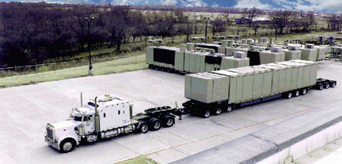

Cogeneration
Providing up to 3,000 kW of electricity and 30,000 lbs/hr of saturated or superheated process steam, the MCU has proven the extraordinary benefits of being able to deliver and install a quality power plant in only a few months. The MCU offers the flexibility and reliability of site built plants, but requires minimal site design and development. This means a fully tested and commissioned cogeneration facility in operation between 8 and 12 months before the competition, which significantly improves the cash flow of the project.
Although the MCU is a standardized product, it has been designed with the flexibility to add site-specific options such as:
- Steam injection for the gas turbines for NOx control and power augmentation
50 or 60 Hz applications
Dual-fuel capability
This flexibility means that the MCU can be operated virtually anywhere around the globe.
With many of these units already in operation around the world, energy Users are realizing the benefits of using equipment with the reliability, quality and performance predictability of the MCU as a hedge against unpredictable energy supplies and ever increasing electricity costs.
All of the units are controlled with the industry leading GE CIMPLICITY control system. This graphical operator interface also allows an optional remote monitoring and control system through conventional modern technology.
Performance Data
Indicative information on the 3MW trailer mounted units:

General
Fuel | Natural gas & Diesel
Modes of operation | Cogen & simple cycle

ISO Performance
Combustion temp | 1,814 deg F (990 deg C)
Air Flow | 17.8 lb/s (8.1 kg/s)
Compression | 9.4 : 1
Exhaust Gas Temp | 964 deg F (518 deg C)
Emissions | 125 ppmvd
Generators | 2 units  50 / 60 Hz  1,800 rpm  1,500 kW @ 4.16 kV each unit  1,875 kVA, 0.8 power factor
Exhaust System
Divertor valve | Flow diversion with noise attenuation
Duct firing | Natural gas or No. 2 Diesel  14.0 mmBTU / hr (3,528 Mcal/hr) max
HRSG
Econimizer | 227 deg F (108 deg C) temp of feed water
Boiler | 29,500 lb/hr (13,409 kg/hr)  250 to 420 psig saturated or super heated
Special characteristics | Removable superheater  Boiler removable for maintenance  Economizer removable for maintenance
Control System | GE FANUC  1 microprocessor for gas turbine PLC  1 microprocessor for boiler and auxiliaries PLC  GE CIMplicity for operator

Performance
Output | 3.166 MW @ 4.16 kV
Fuel consumption | 55 mmBTU / hr LHV
Steam | 33,000 lb/hr saturated @ 250psig, 406 deg F to 420 psig, 452 deg F  29,500 lb/hr superheated @ 250 psig, 565 deg F to 420 psig, 599 F
Auxiliary load | 18 to 150 kW
Noise | 85dBa near field
O&M Contract
Maintenance | 500 hr  4,000 hr  8,000 hr  16,000 hr  32,000 hr

Maintenance | 500 hr  4,000 hr  8,000 hr  16,000 hr  32,000 hr
Training | 1 month
Pricing | Monthly fee with escalation
Water Injection for NOx | 3.2 gpm @ 270 psig (8% power boost)
Steam Injection for NOx | 3,200 lb/h @ 250 psig (14% power boost)
Low Exhaust temp SCR – not included in standard package... additional cost | 7ppmvd Nox @ 15% O2  390 F exhaust from economiser

Guarantees
Delivery & Performance | Not to exceed 2% of Price
Output | $15,000 per unit for each 1% kW
Fuel | $15,000 per 1% of fuel increase

Performance per 1 gas turbine. Each system has 2 units

EXHIBIT “B”
Each 1.5MW gas turbine
Temperature | °F | 60 | 70 | 80 | 90 | 100
 | °C | 15.56 | 21.11 | 26.67 | 32.22 | 37.78
Without injection
Power | KW | 1,415 | 1,334 | 1,267 | 1,183 | 1,101
Fuel | KW/h | 5,985 | 5,763 | 5,584 | 5,370 | 5,165
 | MMBtu/h | 20.43 | 19.67 | 19.06 | 18.33 | 17.63
EGT | °C | 523 | 528 | 532 | 537 | 543
 | °F | 973 | 982 | 990 | 999 | 1,009
EGF | Kg/s | 7.97 | 7.74 | 7.55 | 7.32 | 7.09
 | Lb/h | 63,122 | 61,301 | 59,796 | 57,974 | 56,153
Efficiency | LHV | 23.64% | 23.15% | 22.69% | 22.03% | 21.32%
 | HHV | 21.32% | 20.87% | 20.46% | 19.86% | 19.22%
With water injection
Power | KW | 1,473 | 1,421 | 1,350 | 1,263 | 1,177
Fuel | KW | 6,378 | 6,242 | 6,044 | 5,810 | 5,585
 | MMBtu | 21.77 | 21.30 | 20.63 | 19.83 | 19.06
EGT | °C | 517 | 529 | 533 | 539 | 545
 | °F | 963 | 984 | 991 | 1,002 | 1,013
EGF | Kg/s | 8.05 | 7.80 | 7.60 | 7.36 | 7.13
 | Lb/h | 63,756 | 61,776 | 60,192 | 58,291 | 56,470
Water injection | Kg/h | 461 | 451 | 437 | 420 | 404
 | Lb/h | 1,014 | 992 | 961 | 924 | 889
Efficiency | LHV | 23.10% | 22.77% | 22.34% | 21.74% | 21.07%
 | HHV | 20.83% | 20.53% | 20.14% | 19.60% | 19.00%

All information is estimated. Allow 5% margin for guarantee.

M1A/13A Performance Estimate Single Turbine - MCU 15 based upon standard performance curves for the Kawasaki M1A/13A turbines installed in the mobile cogeneration unit. This computation is based on the following given assumptions:
Two Turbines - MCU 30 Fuel gas, 750 BTU/SCF.

Composition:
- 75% methane
- 23% N2
- 2% CO2

Sea Level
20% Relative Humidity

Temperature range:
- 40 deg C (104 deg F)
- 48 deg C (118 deg F)

The attached table contains the following data:
1. Ambient Temp in deg C
2. Steam injection for power augmentation (on/off)
3. KW at the generator terminals
4. Heat rate expressed in BTU/KW H (kilowatt hour)
5. Standard Cubic Feet per Hour (fuel factor referred to in terms of the heating value based upon the heat rate
6. Exhaust gas temperature
7. Exhaust Flow expressed in pounds per second

 |  | Steam Inj. | KW @ | Heat Rate | Fuel Input | Fuel Input | EGT | Exh. Flow
 | Ambient ºC | Off/On | Gen. Term. | BTU/KWH | BTU/H | SCFH | º F | PPS
Condition 1 | 40 | Off | 1095 | 15989 | 17507818 | 23344 | 1011 | 15.54
Condition 2 | 40 | On | 1217 | 14915 | 18151840 | 24202 | 1015 | 15.65
Condition 3 | 48 | Off | 985 | 16835 | 16582320 | 22110 | 1027 | 14.86
Condition 4 | 48 | On | 1099 | 15635 | 17182832 | 22910 | 1029 | 14.95

Two Turbines - MCU 30

 |  |  | Steam Inj. |  | KW @ | Heat Rate | Fuel Input | Fuel Input | EGT | Exh. Flow
 | Ambient ºC |  | Off/On |  | Gen. Term. | BTU/KWH | BTU/H | SCFH | º F | PPS
Condition 1 | 40 | Off |  |  | 2190 | 15989 | 35015636 | 46688 | 1011 | 31.08
Condition 2 | 40 |  |  | On | 2434 | 14915 | 36303680 | 48405 | 1015 | 31.3
Condition 3 | 48 |  |  | Off | 1970 | 16835 | 33164640 | 44220 | 1027 | 29.72
Condition 4 | 48 |  |  | On | 2198 | 15635 | 34365664 | 45821 | 1029 | 29.9

